Instagram User Analytics

**Project Description:**

The aim of this project was to analyse user activity data from an Instagram-like platform to evaluate user engagement, identify inactive or fake users, and generate meaningful insights for investors and decision-makers. The focus was on understanding posting trends, like behaviours, and detecting potential anomalies (such as bot activity) using SQL.

**Approach:**

The analysis was conducted using **SQL queries** in **MySQL Workbench** to extract and analyse data from a relational database containing user, photo, like, and tag information.

The process involved:

* Understanding database schema and relationships.
* Writing optimized SQL queries to answer business questions.
* Interpreting data patterns to derive insights.

**Tech-Stack Used:**

Used SQL and MySQL Workbench as tool to analyse Instagram user data and answer questions posted by the management team.

**Insights:**

Through this project, several key insights were discovered using only SQL fundamentals:

* Average posts per user and the ratio of photos to users, which helped evaluate overall activity.
* Identification of top 5 oldest loyal users based on account creation and posting activity.
* Detection of inactive users (users with no photo posts).
* Flagging of potential fake or bot users, particularly those who liked every single photo on the platform — behaviour not typical of genuine user engagement.

This analysis showed how powerful and insightful raw data can be when queried effectively.

**Result:**

* Successfully created SQL queries to answer investor-focused questions.
* Gained hands-on experience in data extraction and pattern recognition using MySQL.
* Developed a deeper understanding of identifying anomalies and engagement trends in user behaviour.
* The project reinforced how simple, structured queries can unlock high-value business insights from raw data.

This analysis can support decision-making around user engagement strategies, bot detection, and platform health monitoring.

**Drive Link:**

<https://drive.google.com/drive/folders/14xSZWZNHClp0jGWfHGRozjF67axRZMNB?usp=drive_link>

SQL Tasks: - Marketing Analysis

1. Loyal User Reward task: Identify the five oldest users on Instagram from the provided database:

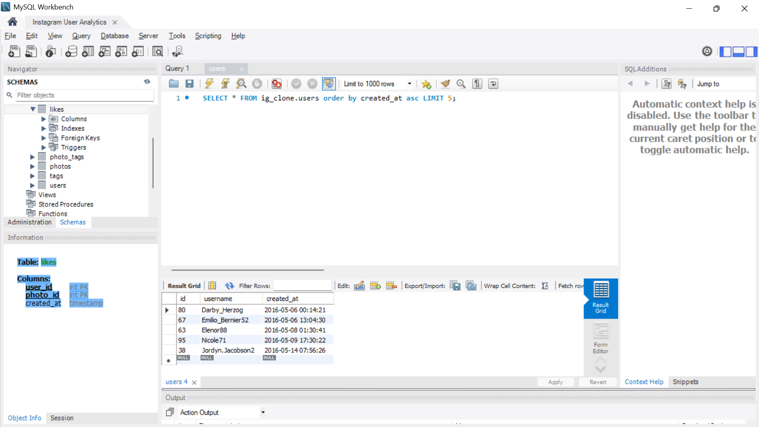

2. Inactive User Engagement Task:  Identify users who have never posted a single photo on Instagram.

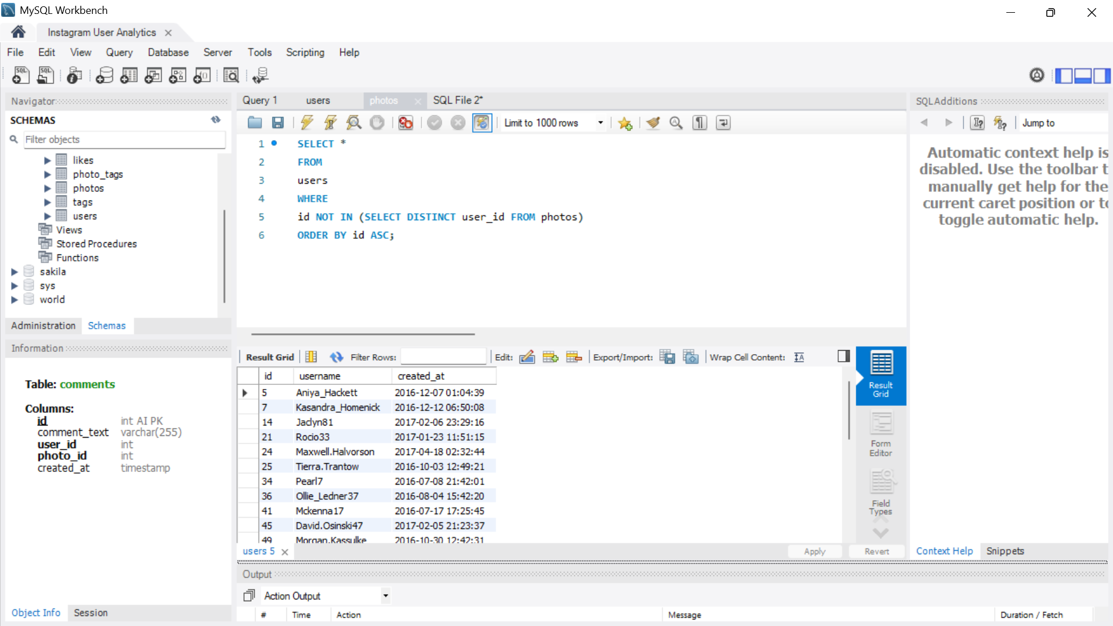

3. Contest Winner Declaration Task: The team has organized a contest where the user with the most likes on a single photo wins. Determine the winner of the contest and provide their details to the team.

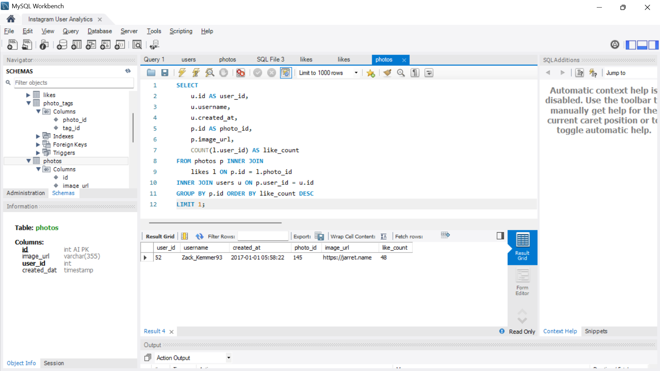

Insights: The winner of the contest for the user with the most likes on a single photo is **Zack_Kemmer93**

4. HashTags Research Task: A partner brand wants to know the most popular hashtags to use in their posts to reach the most people. Identify and suggest the top five most commonly used hashtags on the platform.

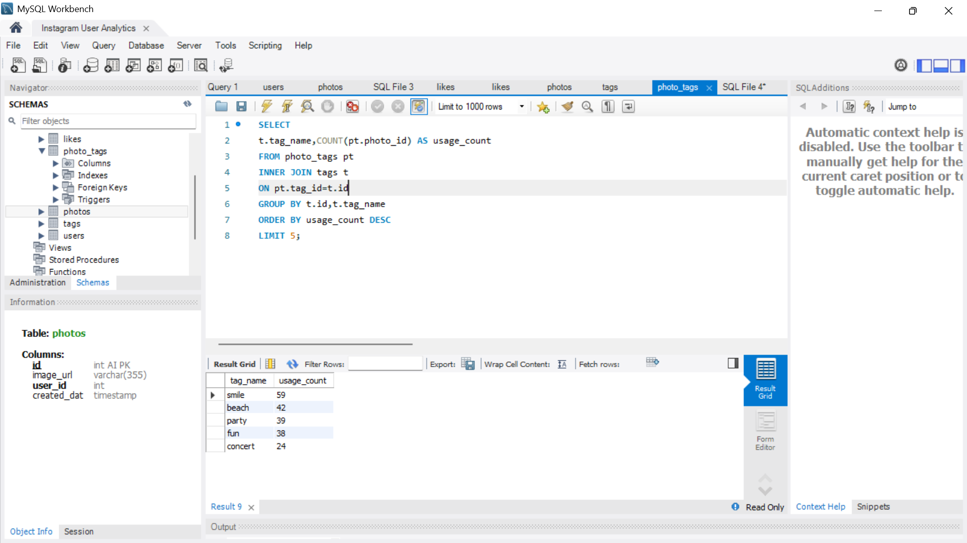

Insights: The Five most popular hashtags used in the posts to reach maximum people are as: **#smile, #beach, #party, #fun, #concert**

5. Ad Campaign Launch Task: The team wants to know the best day of the week to launch ads. Determine the day of the week when most users register on Instagram. Provide insights on when to schedule an ad campaign.

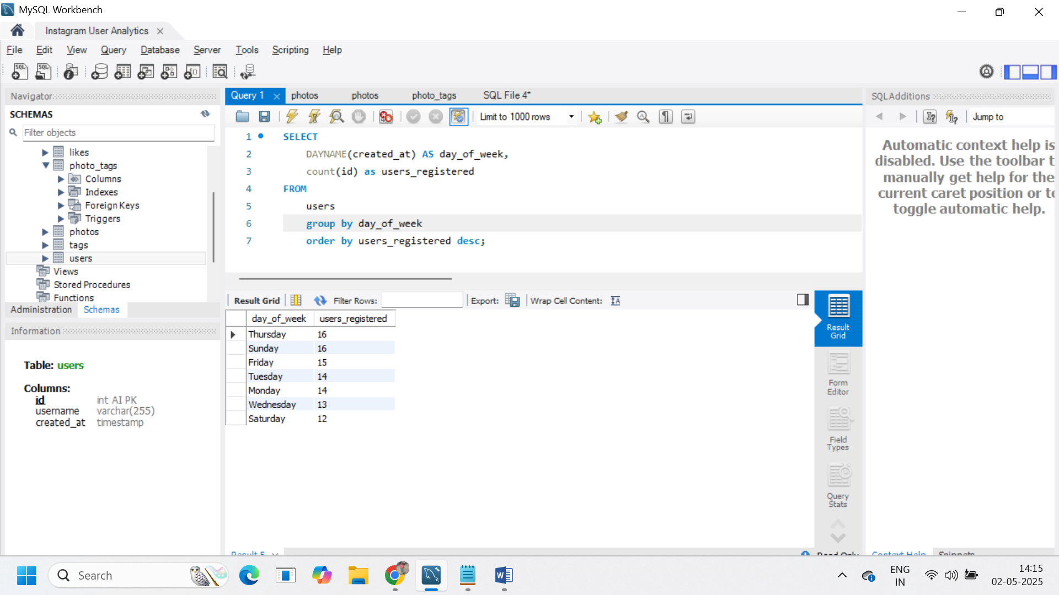

Insights: Most of the users have registered on Instagram are on Thursdays and Sundays. Hence best day of a week to schedule an AD Campaign would be **Thursday and Sunday**.

SQL Tasks: - Investors Metrics

1. User Engagement: Investors want to know if users are still active and posting on Instagram or if they are making fewer posts.

Your Task: Calculate the average number of posts per user on Instagram. Also, provide the total number of photos on Instagram divided by the total number of users.

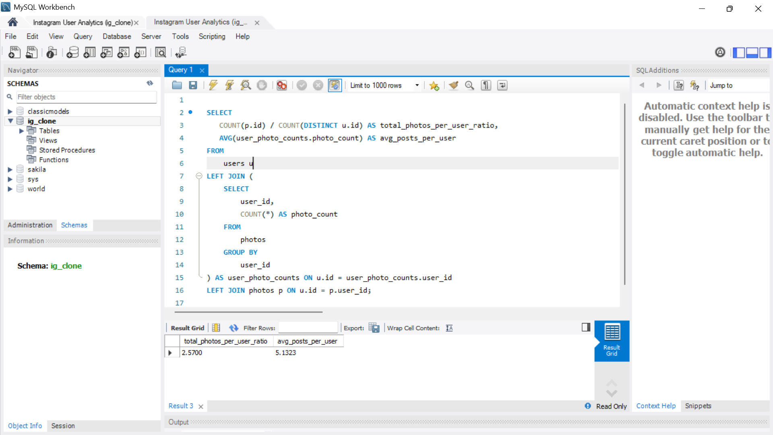

Insights: Average number of posts per user on Instagram is **5.1323** and the total number of photos on Instagram divided by the total number of users is **2.5700**

Bots & Fake Accounts:  Investors want to know if the platform is crowded with fake and dummy accounts.

Your Task: Identify users (potential bots) who have liked every single photo on the site, as this is not typically possible for a normal user.

